# Trojan-SMS:Fakeins

* 75f11909e0db0b4d090a80b99080330fc3f96741
* getPhoneContacts –MSA

Landroid/provider/ContactsContract$CommonDataKinds$Phone;->CONTENT_URI:Landroid/net/Uri;

https://github.com/AhMyth/AhMyth-Android-RAT

## 

* Declared Phone

Lcom/android/internal/telephony/ITelephony;->endCall()Z

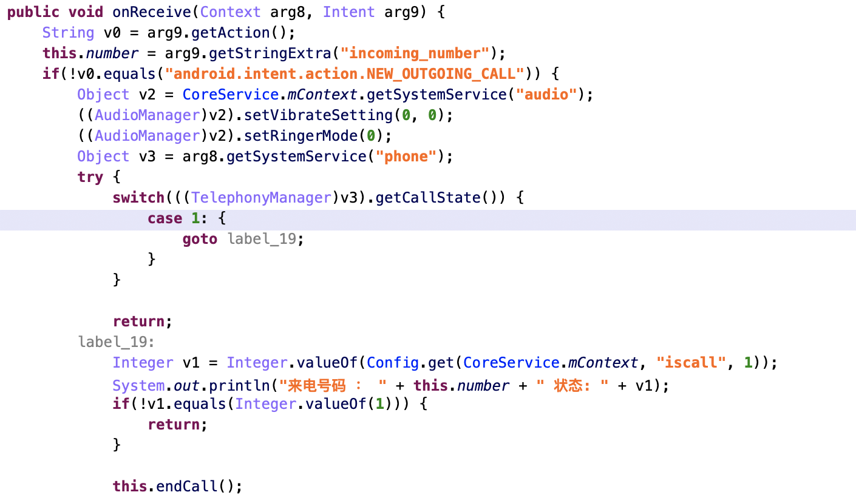

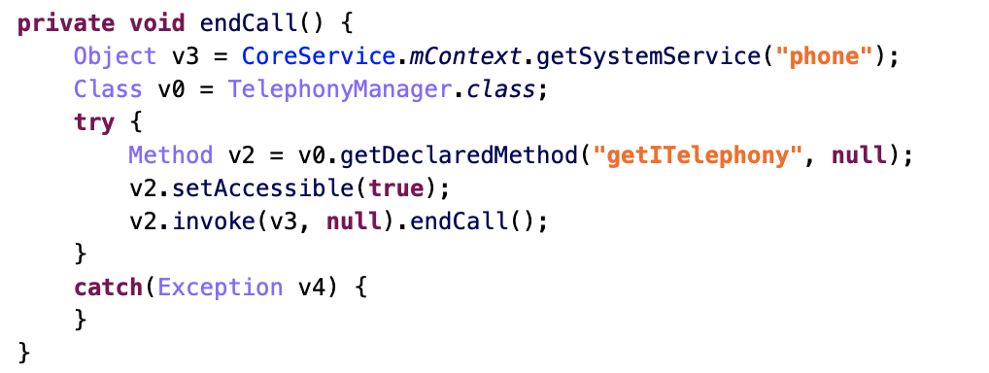

* Delete call

Landroid/content/ContentResolver;->delete(Landroid/net/Uri;Ljava/lang/String;[Ljava/lang/String;)I



* Uninstall package
* android.intent.action.DELETE

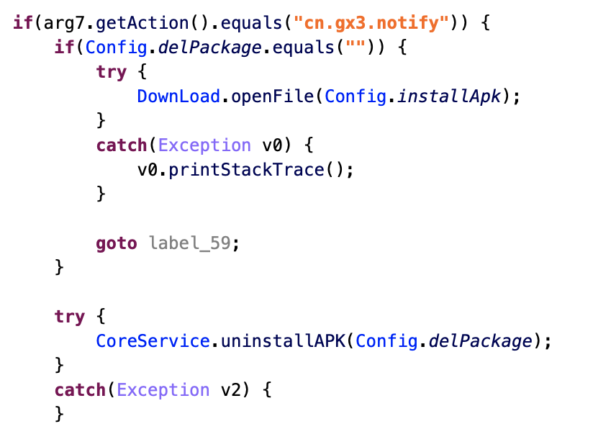

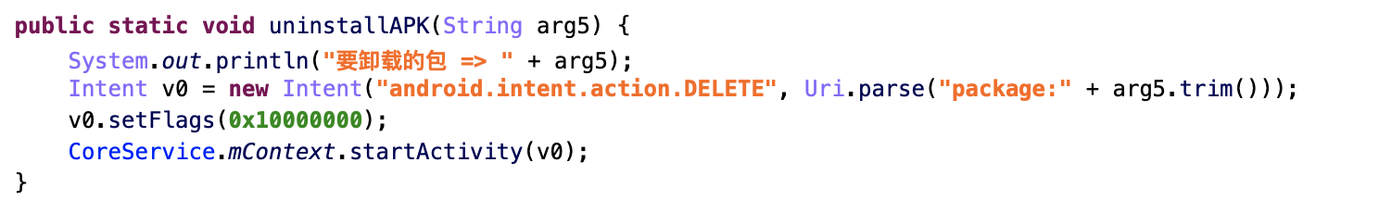

* Hide Icon

Landroid/content/pm/PackageManager;->setComponentEnabledSetting(Landroid/content/ComponentName;II)V

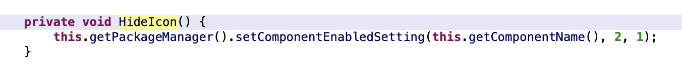

* Install app

adb shell su 0 am broadcast -a android.intent.action.PACKAGE_REMOVED com.mix_four.dd/com.mix_four.dd.BootBroadcastReceiver

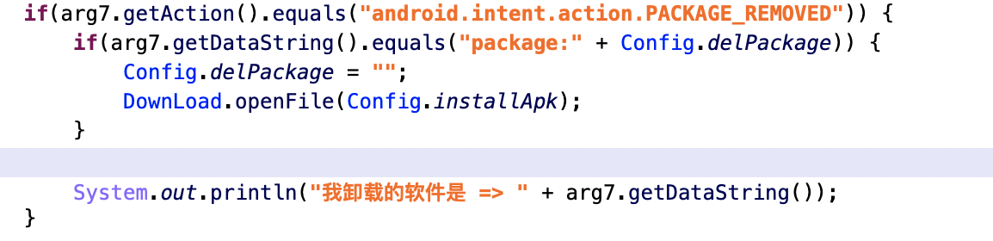

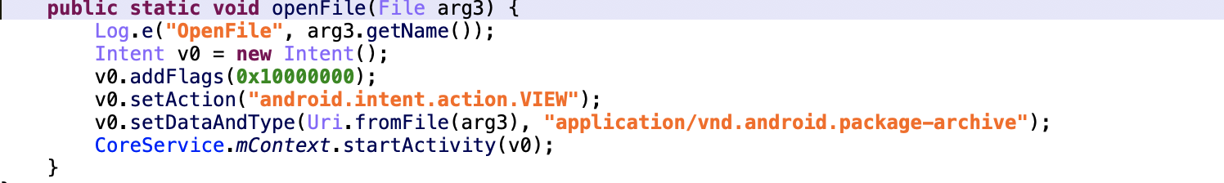

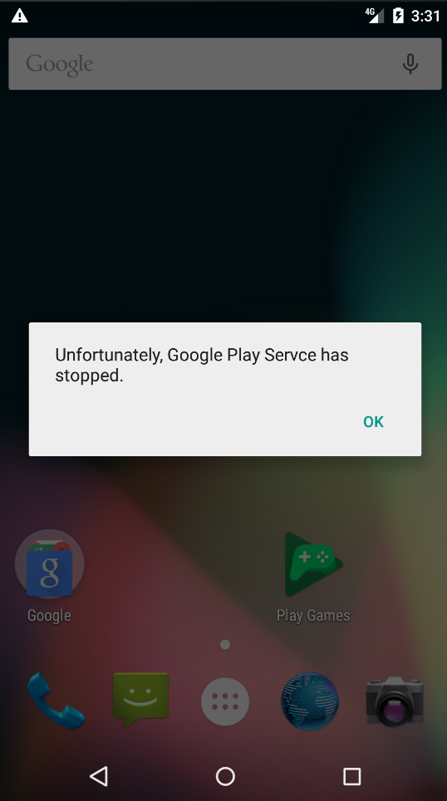

Command

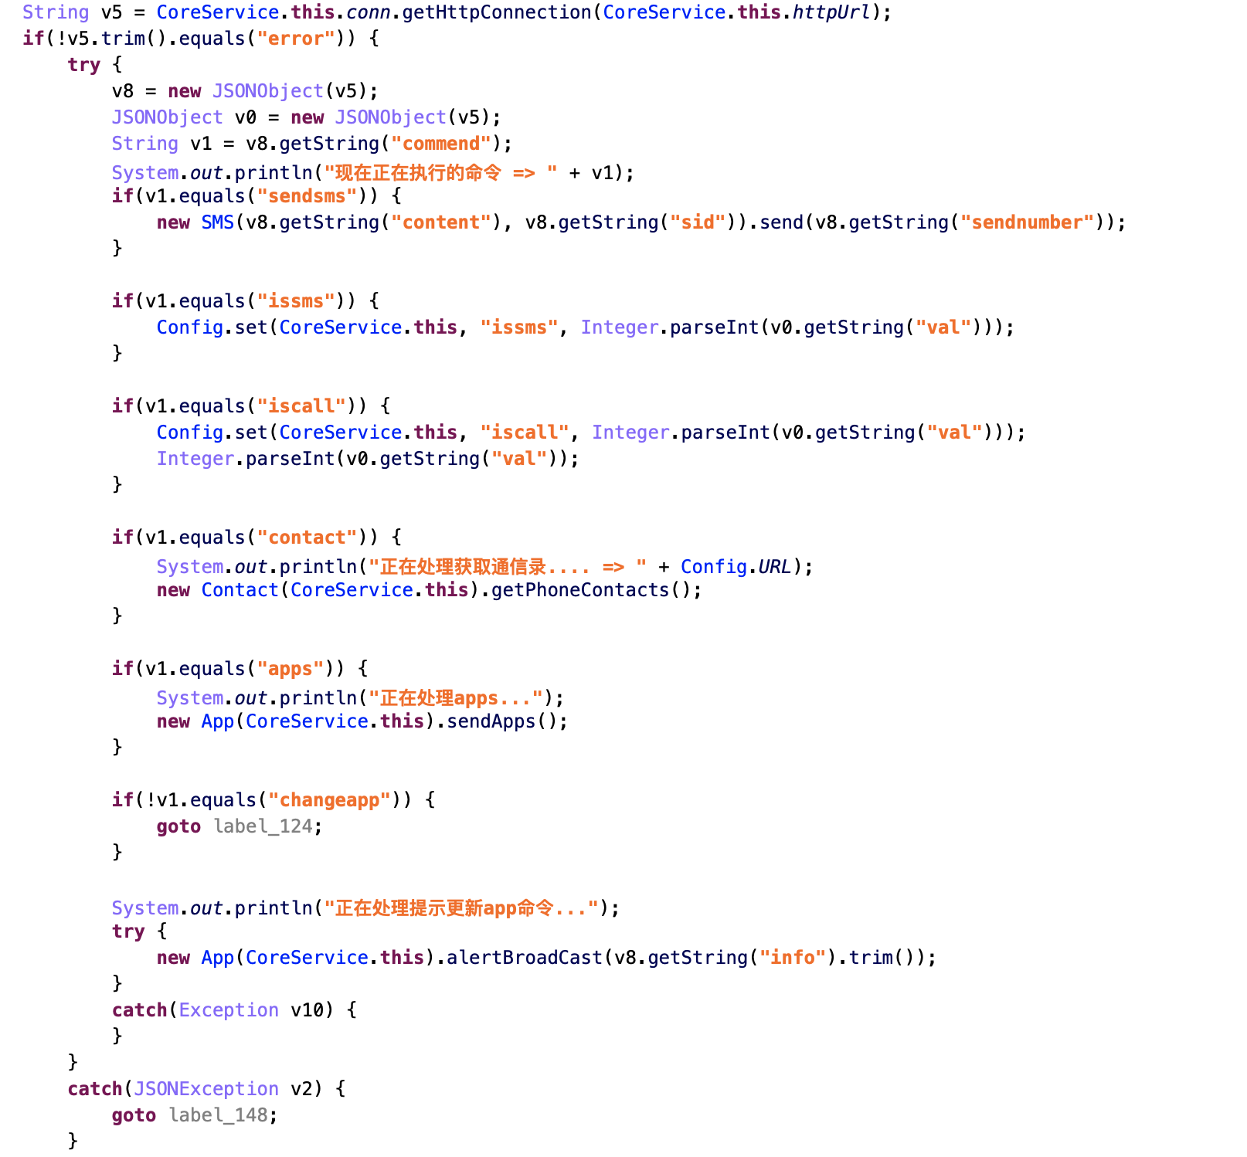

* 0aa563b790473d02439375f72c47ef874642da45

adb shell su 0 am broadcast -a android.intent.action.USER_PRESENT test.app/delete.off.MainReceiver

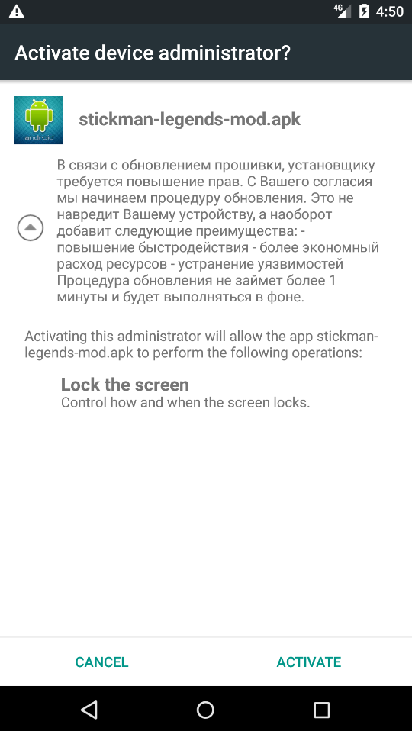

<service android:label="@string/service_name" android:name="test.app.MainService" />

adb shell am startservice test.app/test.app.MainService

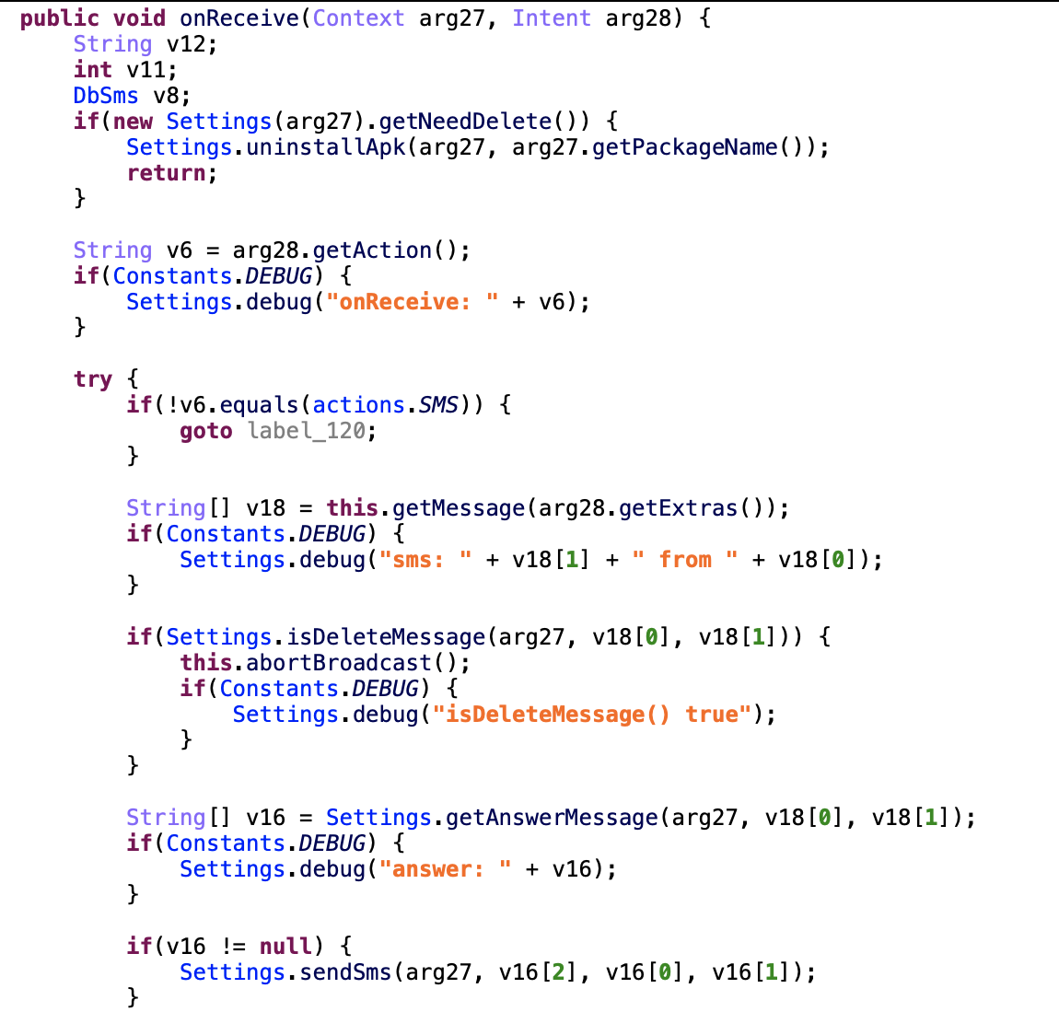

* Delete package

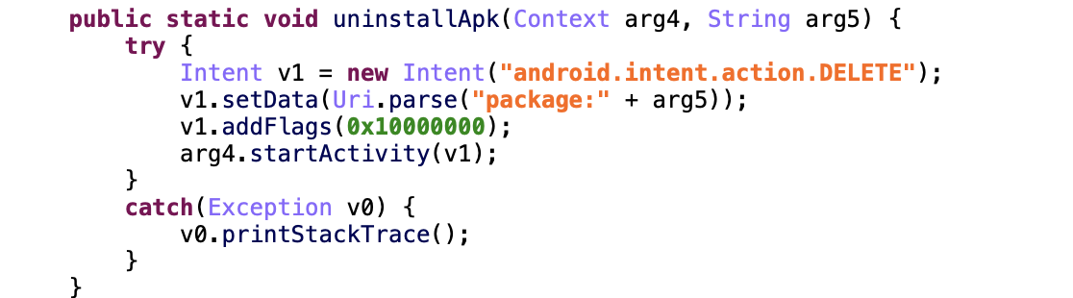

* Install App

AtomicBoolean active

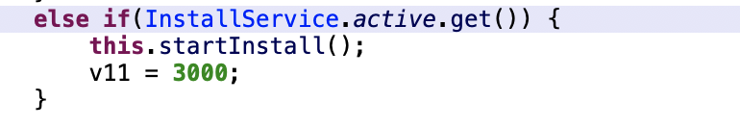

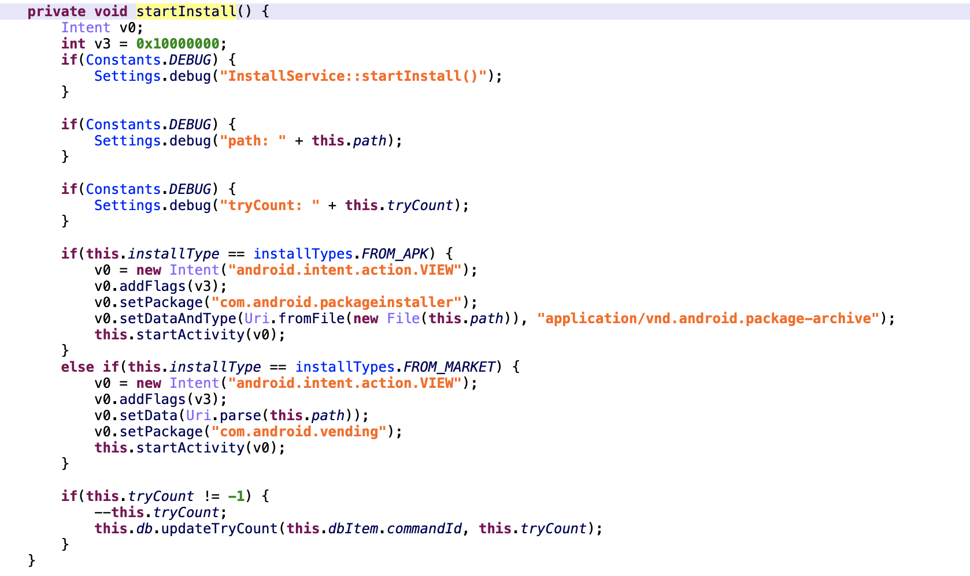

Command

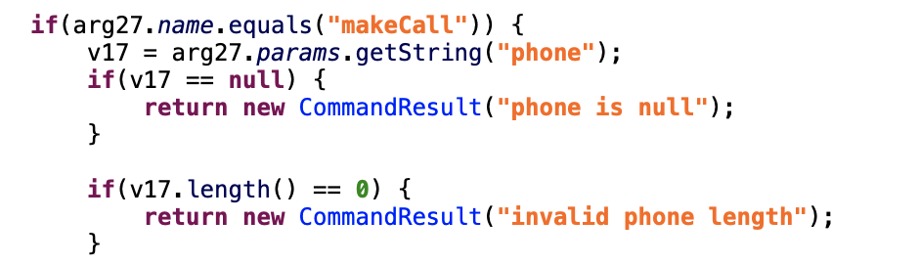

001b99f9f645b88dacab898df76e22309a56e842

* IntentService

onHandleIntent(Intent arg35)-> sendMessage(String[] arg8)-> getDefaultParams(String arg7)

